Save the Date!!!

Full day training coming to the Nexsource Centre,4823 49th street in Sylvan Lake!

**October 5, 2018**

Intergenerational Sensitivity Training

Cost is $25 per person and includes;

* train-the-trainer Intergenerational Sensitivity Training * snacks, coffee and lunch * how to create programs that build relationships between youth and seniors

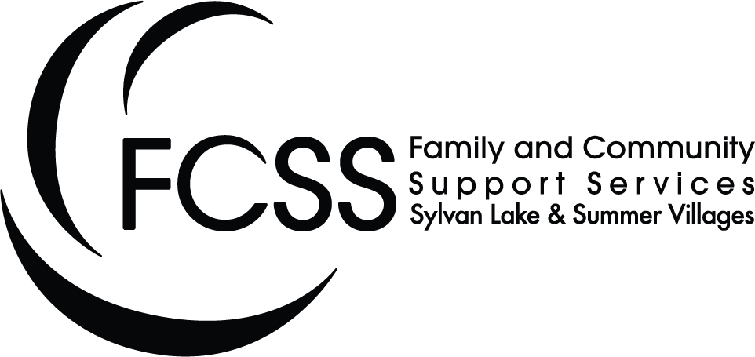

For more information contact Leanne 403 887 1137 ext.232 or e-mail llyon@sylvanlake.ca